# Create SQL queries to transform data using MariaDB.

## Environment preparation

1 ) As the environment will spin-up with docker you need to install it, register and sign in.

<https://www.docker.com/get-started>

2)Once docker desktop is up and running, take docker-compose.yml (should be provided separately) and copy somewhere on your local hard drive.

Here is the content of docker-compose.yml

version: "2"

services:

db:

image: mariadb:10.5.4

ports:

- "3306:3306"

environment:

MYSQL_DATABASE: myDb

MYSQL_USER: user

MYSQL_PASSWORD: test

MYSQL_ROOT_PASSWORD: test

volumes:

- ./dump:/docker-entrypoint-initdb.d

- persistent:/var/lib/mysql

networks:

- default

phpmyadmin:

image: phpmyadmin/phpmyadmin

links:

- db:db

ports:

- 8000:80

environment:

MYSQL_USER: user

MYSQL_PASSWORD: test

MYSQL_ROOT_PASSWORD: test

volumes:

persistent:

3)Open command line -> go to the directory where you’ve unarchived the docker files and execute the following commands(wait till completion before executing the next command):

* docker-compose up

Then wait till docker image is downloaded and started

After that run

* docker ps

In the end you should see the following

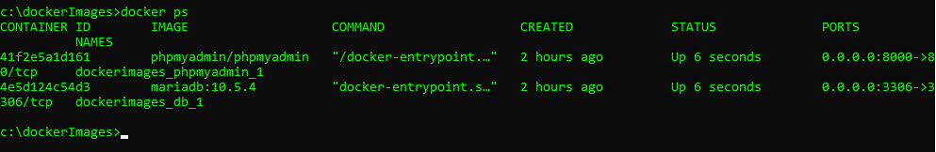

If you are the Windows user, docker containers and its state can be monitored using docker UI dashboard.

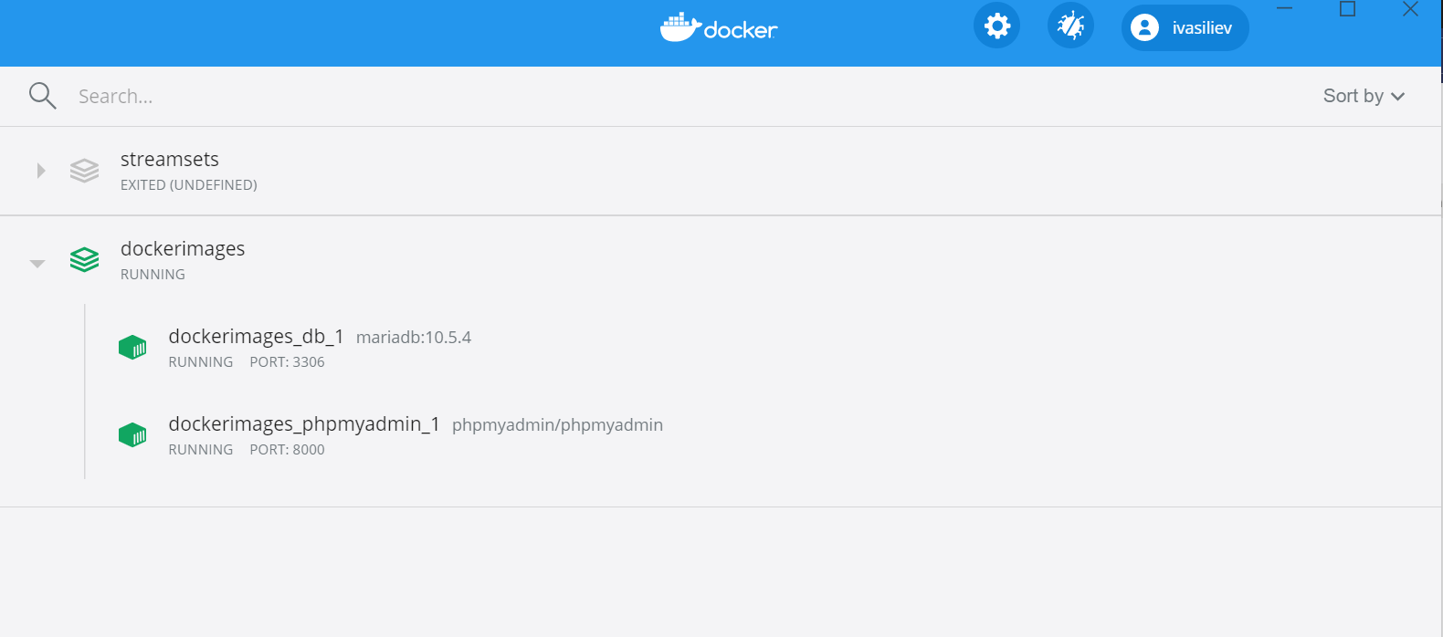

4)Services will be available by the following paths:

MariaDB http://localhost:3306/ user: root password: test

phpmydamin: <http://localhost:8080/>

Please note: if the ports mentioned above are in use, you’ll need to change them in docker-compose.yml and repeat point 3.

5)Login to phpMyAdmin and connect to MariaDb using credentials from the above

## Task.

1)Create database from nation.sql script

2)Using the data from nation database create the table ‘countryRank’ that will display

Ranking of countries by its area from largest to smallest. Ranking shold be calculated for regions and continent.

a)National holiday field shouldn’t contain NULL values, put ‘no data insead’

b)If notional holiday contains the date in future it should be changed to current date

c)Get rid of the duplicates

Provide sql scrpits and screenshots as evidence.

3)Answer the question – what can be done on a database level to avoid problems with duplicates and Null values?

The expected result should look like this.

